Design Document - WorldFileTool

Short description of each Package

…/junit:
WorldFileToolTest.java JUnit Tests

…/logic:
Data.java Object to save Contents
KML.java import/ export KML-file
WorldFile.java import/ export WorldFile

…/ui:
About.java About Box
GUI_Swing.java FrontEnd Swing

…/util:
RotateImage.java Rotate Image

Detailed description of the interesting Classes

…/util/RotateImage.java
- rotate_vectors:
  - vecx, vecy vector with x, y coordinates

The vectors will be converted with some simple math into an angle which is used to rotate an image.

- rotate_angle: Using an angle to rotate an image.

- translate: Rotating increases the image size, so some part of it will be out of
bound, therefore a translation is needed to put the whole image into a visible position.

- rotate_translate: Rotate the image and call translate.

…/logic/KML.java
- parse_kml: read a kml and extract the needed parts.

- write_kml: writes a kml and add some new data

…/logic/Data.java
- calc_new_values: rotating an image increases the image size, thus the coordinates
needs to be recalculated.

…/logic/WorldFile.java
- parse_worldfile: parse a worldfile and check if the coordinates are in the geographic
coordinate system.

- write_wf: writes a worldfile with the new data.
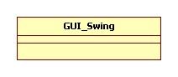
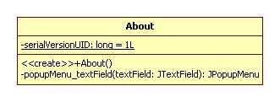
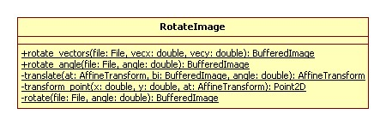
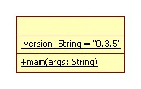
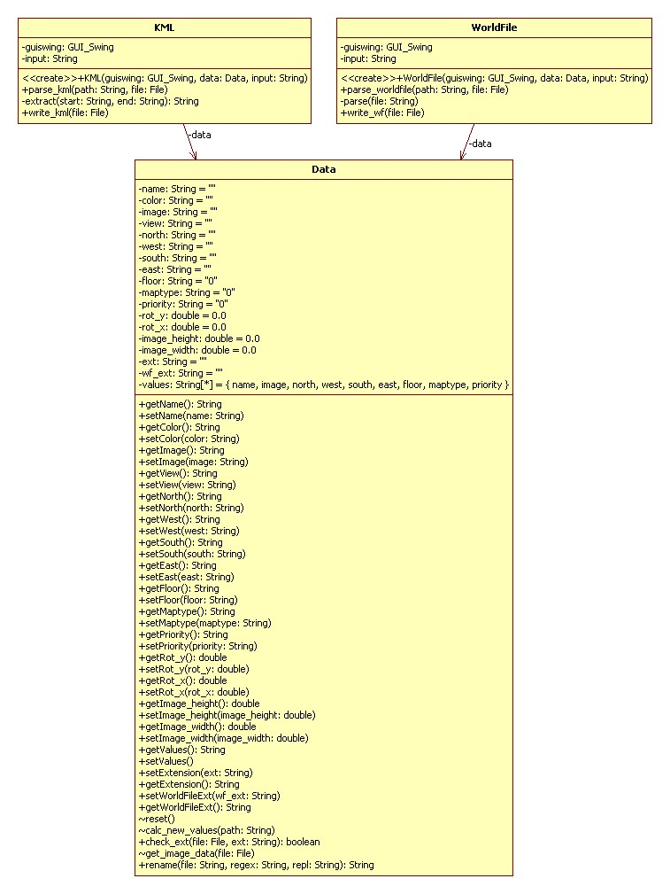
WorldFileTool

